Chinese Medicine for Coronavirus Disease 2019 (COVID-19): An Updated and GRADE-Assessed Systematic Review and Meta-Analysis

Jianbo Guoª, Zongshi Qinª, Ngai Chung Lauª, Tung Leong Fongª, Wei Meng^{a, c, d}, Zhang-Jin Zhang^{a,b}, Yi Luoª, Vivian Chi-Woon Taam Wongª, Yibin Fengª, Haiyong Chen^{a,b}

ª School of Chinese Medicine, LKS Faculty of Medicine, The University of Hong Kong, Hong Kong, China
^{b} Department of Chinese Medicine, The University of Hong Kong-Shenzhen Hospital, Shenzhen, China
^{c} Hong Kong Branch of Workstation of Distinguished Professor Yu Jin for Training and Research in Integrative Gynaecology, Hong Kong, China
^{d} Hong Kong Branch of the Work Station of National Master Zhu Nansun for Chinese Medicine Gynaecology, Hong Kong, China

Correspondence to: Dr. Haiyong Chen, School of Chinese Medicine, LKS Faculty of Medicine, The University of Hong Kong, 10 Sassoon Road, Pokfulam, Hong Kong 999077, China.

Abstract
Coronavirus disease 2019 (COVID-19) is a huge ongoing public health concern globally. This study aims to update the evidence for Chinese medicine (CM) against COVID-19. Eleven databases were searched on June 30, 2021. An initial search of 4180 studies was conducted and the final number of included studies remained at 52. The statistical methods and analysis of the combined results remained unchanged. The RoB 2.0, ROBINS-I and GRADE tools continued to be used to assess risk and level of evidence. The findings with the moderate certainty in GRADE showed that compared with routine treatment (RT), Lianhua Qingwen granules (LHQW) adjunctive to RT showed a significantly improved efficacy rate (Relative risk (RR) = 1.19, 95% confidence interval (CI) [1.09, 1.31]), febrile score (standard mean difference (SMD) = - 1.21, 95% CI [- 1.43, -0.99]), and computerized tomography (CT) lung images (RR= 1.23, 95% CI [1.10, 1.38]); Qingfei Paidu decoction (QFPD) plus RT significantly shortened the length of hospital stay (SMD = - 1.83, 95% CI [- 2.18, - 1.48]); Feiyan Yihao formula (FYYH) plus RT significantly improved the clinical efficacy rate (RR= 1.07, 95% CI [1.00, 1.15]), and time to negative PCR test for COVID-19 (SMD = - 0.72, 95% CI [- 0.94, - 0.51]). Adjunctive effects of CM with lower certainty of evidence were found, including improvements in symptoms, laboratory outcomes and mortality. No adverse events or minor adverse events were observed in the majority of studies. In conclusion, the current evidence remains unchanged that CM formulations, particularly LHQW, QFPD and FYYH, have an adjuvant effect on standard treatment of COVID-19.

Keywords: COVID-19; Chinese medicine; Lianhua Qingwen; Feiyan Yihao; Qingfei Paidu; systematic review; meta-analysis
Introduction
Coronavirus disease 2019 (COVID-19), caused by Severe Acute Respiratory Syndrome Coronavirus 2 (SARS-COV-2), has greatly affected the world [1, 2], as well as the enormous research and medical challenges posed by its several mutant strains [3, 4]. According to data reported by the World Health Organization on June 28, 2021, more than 183 million people are infected worldwide, resulting in more than 3.9 million deaths. Chinese medicine (CM) has played a crucial role in the treatment of several pandemics throughout history, including fever amelioration in patients with influenza A (H1N1) virus infection, and lung infiltration improvement in patients with severe acute respiratory syndrome (SARS) [5-8]. For patients with different CM syndromic diagnosis, China’s National Health Commission included CM in the COVID-19 management guidelines (Diagnosis and Treatment Protocol for Novel Coronavirus Pneumonia, Trial Version 3) in March 2020 and made corresponding treatment recommendations.
Previous systematic reviews have shown that CM prescriptions in combination with western medicine significantly improve clinical symptoms [9-11]. As more studies are published, the systematic reviews need to be updated regularly. These newly published studies followed China’s guidelines for treatment and diagnosis of COVID-19, which might reduce the heterogeneity among studies. In our published systematic review [12], we showed that at least three formulas, Lianhua Qingwen, Feiyan Yihao and Qingfei Paidu, have moderate level of evidence to improve COVID-19 symptoms. This study aims to provide an update of the systematic review.

Methods
Search Strategy
This review was registered in PROSPERO on March 27, 2020 (registered no. CRD42020176347) and followed the Preferred Reporting Items for Systematic Reviews and Meta-Analyses (PRISMA) statement [13]. Eleven databases were searched by June 30, 2021, including PubMed, Excerpta Medica Database, Cochrane Library, Allied and Complementary Medicine Database, Cumulative Index to Nursing & Allied Health Literature Plus, Chinese National Knowledge Infrastructure Database, China Scientific Journal Database, Wanfang Database, ClinicalTrials.gov, Chinese Clinical Trial Registry, and MedRxiv. The specific search strategy is the same as in the previously published version [12].

Eligible Criteria, Literature Quality Assessment, and Data Extraction and Analyses
The inclusion and exclusion criteria remained unchanged from the previous study methodology [12]. The quality assessment of the literature also remained the same as in the previous study, including the use of the RoB 2.0 and ROBINS-I tools for risk bias assessment of randomised controlled trials and retrospective intervention studies respectively. The EndNote software (version X9.3.3) was still used as a tool for screening the literature. As in the previous study [12], the Stata 17.0 software (Stata Corp., College Station, TX, USA) was used for the combined analysis of data.

Results
Literature Selection and Characteristics
This update retrieved 4,180 studies in the initial search and 2,757 studies were left after removing duplicates. Next we screened titles, abstracts and full text respectively, 52 studies meeting the selection criteria were included. The flow chart of the screening and reasons for exclusion are shown in Fig 1. In the full text assessment, specific reasons for exclusion were as follows: lack of matched control group (28 studies), lack of comparison of CM efficacy (30 studies), presence of CM in the control group (3 studies), and withdrawal of the publication (1 study).
Compared to the search on April 30, 2021 [12], no new eligible studies were included. There were 52 studies, including 12 [14-25] and 40 published in English and Chinese, respectively, enrolling 5,634 patients. 3,389 patients received CM or CM adjunctive to RT in the treatment group, while 2,245 patients received RT in the control group. Thirty-six studies reported that both groups received interventions for 3 to 28 days, while the remaining 16 studies did not report such details. The sample sizes of the included studies ranged from 22 to 563.
Individualized CM formulae were still administered in 15 studies [17, 18, 26-38]. Moreover, 37 studies used the CM formulae described in China’s guidelines for COVID-19 and CM classic formulae, including Lianhua Qingwen granules (LHQW), Jinhua Qinggan granules (JHQG), Feiyan Yihao formula (FYYH), Reyanning granules (RYN), Reduning injection (RDN), Shenmai injection (SM), Buzhong Yiqi decoction (BZYQ), Shuanghuanglian oral liquids (SHL), Huashi Baidu decoction (HSBD), Keguan-1 formula (KG-1), Huoxiang Zhengqi granules (HXZQ), Xuanfei Baidu decoction (XFBD), Xiyanping injection (XYP), Xuebijing injection (XBJ), Shufeng Jiedu formula (SFJD), Qingfei Paidu decoction (QFPD), and Jinye Baidu formula (JYBD). Therefore, the results of the meta-analysis remain unchanged compared to our published study.

Discussion
In the updated study, no eligible studies were included for meta-analysis. Results remain unchanged from our previous publication [12]:
1. LHQW plus RT significantly improved COVID symptoms (i.e., febrile score, fever level and symptoms of dyspnea, appetite, chest tightness, expectoration, and muscle pain), and chest imaging outcomes. The pooled studies indicated significant improvement of cough score and fatigue recovery time by LHQW, but there were high heterogeneity among those studies.
2. Compared with RT alone, the FYYH adjunctive to RT shortened the time to the negative PCR test (0.72 d), and restored lymphocytes in patients with a moderate evidence level.
3. The QFPD plus RT lowered laboratory indexes (i.e., CRP level, lymphocyte indices and CT images), shortened the hospital stay, and might reduce mortality (zero vs. four deaths).
4. The XBJ adjunctive to RT lowered CRP and improved WBC.

Conclusion
The moderate certainty level in GRADE shows that CM formulae have adjunctive effects on COVID-19, particularly clinical symptoms, clinical efficacy, severity, and duration of disease. Adjunctively to RT, the FYYH improves the clinical efficacy rate, and time to negative PCR test; QFPD shortens the hospital stay, improves CT lung images and mortality; LHQW improves the clinical efficacy rate, febrile score, and severity of CT lung scan.

Acknowledgments
This study was supported by the Chinese Medicine Development Fund (19SB2/012A).

References
1. Wang, C., et al., A novel coronavirus outbreak of global health concern. Lancet, 2020. 395(10223): p. 470-473.
2. Lu, R., et al., Genomic characterisation and epidemiology of 2019 novel coronavirus: implications for virus origins and receptor binding. Lancet, 2020. 395(10224): p. 565-574.
3. Bhattacharyya, R.P. and W.P. Hanage, Challenges in Inferring Intrinsic Severity of the SARS-CoV-2 Omicron Variant. N Engl J Med, 2022. 386(7): p. e14.
4. Hart, W.S., et al., Generation time of the alpha and delta SARS-CoV-2 variants: an epidemiological analysis. Lancet Infect Dis, 2022.
5. Liu, P., et al., China's distinctive engagement in global health. Lancet, 2014. 384(9945): p. 793-804.
6. Wang, C., et al., Oseltamivir compared with the Chinese traditional therapy maxingshigan-yinqiaosan in the treatment of H1N1 influenza: a randomized trial. Ann Intern Med, 2011. 155(4): p. 217-25.
7. Duan, Z.P., et al., Natural herbal medicine Lianhuaqingwen capsule anti-influenza A (H1N1) trial: a randomized, double blind, positive controlled clinical trial. Chin Med J (Engl), 2011. 124(18): p. 2925-33.
8. Liu, X., et al., Chinese herbs combined with western medicine for severe acute respiratory syndrome (SARS). Cochrane Database Syst Rev, 2012. 10(10): p. Cd004882.
9. Yin, B., et al., Efficacy of integrated traditional Chinese and western medicine for treating COVID-19: a systematic review and meta-analysis of RCTs. Front Public Health, 2021. 9: p. 622707.
10. Zhou, L.P., et al., The effects of traditional Chinese medicine as an auxiliary treatment for COVID-19: a systematic review and meta-analysis. J Altern Complement Med, 2021. 27(3): p. 225-237.
11. Wang, H., et al., Efficacy and safety of traditional Chinese medicine in coronavirus disease 2019 (COVID-19): a systematic review and meta-analysis. Front Pharmacol, 2021. 12: p. 609213.
12. Guo, J., et al., Chinese Medicine for Coronavirus Disease 2019 (COVID-19): A GRADE-Assessed Systematic Review and Meta-Analysis. Am J Chin Med, 2022. 50(1): p. 1-31.
13. Liberati, A., et al., The PRISMA statement for reporting systematic reviews and meta-analyses of studies that evaluate health care interventions: explanation and elaboration. Ann Intern Med, 2009. 151(4): p. W65-94.
14. Wang, J.B., et al., Exploring an Integrative Therapy for Treating COVID-19: A Randomized Controlled Trial. Chin J Integr Med, 2020. 26(9): p. 648-655.
15. Xiao, M.Z., et al., Efficacy of Huoxiang Zhengqi dropping pills and Lianhua Qingwen granules in treatment of COVID-19: a randomized controlled trial. Pharmacol Res, 2020. 161: p. 105126.
16. Xiong, W.Z., et al., Efficacy of herbal medicine (Xuanfei Baidu decoction) combined with conventional drug in treating COVID-19: a pilot randomized clinical trial. Integr Med Res, 2020. 9(3): p. 100489.
17. Zhang, H.T., et al., Evaluation of the Adjuvant Efficacy of Natural Herbal Medicine on COVID-19: A Retrospective Matched Case-Control Study. Am J Chin Med, 2020. 48(4): p. 779-792.
18. Li, L., et al., Effects of Chinese Medicine on Symptoms, Syndrome Evolution, and Lung Inflammation Absorption in COVID-19 Convalescent Patients during 84-Day Follow-up after Hospital Discharge: A Prospective Cohort and Nested Case-Control Study. Chin J Integr Med, 2021. 27(4): p. 245-251.
19. Huang, L., Efficacy and safety assessment of severe COVID-19 patients with Chinese medicine: a retrospective case series study at early stage of the COVID-19 epidemic in Wuhan, China. J Ethnopharmacol, 2021: p. 113888.
20. Guo, H., et al., Xuebijing injection in the treatment of COVID-19: a retrospective case-control study. Ann Palliat Med, 2020. 9(5): p. 3235-3248.
21. Xu, X., et al., Efficacy and safety of Reduning injection in the treatment of COVID-19: a randomized, multicenter clinical study. Ann Palliat Med, 2021.
22. Feng, J., et al., Clinical Effect of Traditional Chinese Medicine Shenhuang Granule in Critically Ill Patients with COVID-19: A Single-Centered, Retrospective, Observational Study. J Microbiol Biotechnol, 2021. 31(3): p. 380-386.
23. Hu, K., et al., Efficacy and safety of Lianhuaqingwen capsules, a repurposed Chinese herb, in patients with coronavirus disease 2019: A multicenter, prospective, randomized controlled trial. Phytomedicine, 2021. 85: p. 153242.
24. Liu, Z., et al., Effect of Jinhua Qinggan granules on novel coronavirus pneumonia in patients. J Tradit Chin Med, 2020. 40(3): p. 467-472.
25. Ni, L., et al., Effects of Shuanghuanglian oral liquids on patients with COVID-19: a randomized, open-label, parallel-controlled, multicenter clinical trial. Front Med, 2021: p. 1-14.
26. Jin, W., et al., The efficacy of recommended treatments with integrated Chinese and western medicine on coronavirus disease 2019 (COVID-19) in Sichuan: a clinical trial observation. Pharmacol. Clin. Chin. Mater. Med., 2020. 36(6): p. 6-10.
27. Lian, J., et al., Retrospective analysis of 38 cases with coronavirus disease 2019 treated by integrated traditional Chinese and western medicine. J. Tradit. Chin. Med., 2020. 61(24): p. 2126-2130.
28. Liao, G.R., Study on application effect and safety of self-prepared traditional Chinese medicine decoction in patients with COVID-19. Int. Infect. Dis., 2020. 9(2): p. 353.
29. Liu, F., Observation on the curative effect of integrated traditional Chinese and western medicine on COVID-19 42 cases. Zhongguo Guanli Kexue Yanjiuyuan Shangxueyuan Guanli Chuangxin Chengguo Huibian, 2020. 202: p. 1-7.
30. Pan, G.T., et al., Integrated traditional Chinese and western medicine in the treatment of 40 cases of critical patients with COVID-19. Acta Med. Univ. Sci. Technol. Huazhong, 2020. 49(2): p. 202-207.
31. Qin, L.X., et al., Clinical characteristics, drug treatments and prognoses in 605 patients with severe and critical corona virus disease 2019 in Hubei, China: a multi-center, retrospective, cohort study. Chin. Arch. Tradit. Chin. Med., 2021. 39(3): p. 89-95.
32. Shi, J., et al., Clinical observation on 49 cases of non-critical COVID-19 in Shanghai treated by integrated traditional Chinese and western medicine. Shanghai J. Tradit. Chin. Med., 2020. 54(4): p. 30-35.
33. Song, X.Y., Clinical retrospective study on novel coronavirus pneumonia treated with Sanjiao treatment. Hubei Univ. Chin. Med., 2020: p. 1-65.
34. Wang, L., et al., Clinical study on Shengmai powder combined with Shenling Baizhu powder in the treatment of common corona virus disease 2019. China J. Tradit. Chin. Med. Pharm., 2020. 35(8): p. 4268-4271.
35. Yang, Q., et al., Retrospective clinical study on treatment of COVID-19 patients with integrated traditional Chinese and western medicine. Chin. Tradit. Herb. Drugs, 2020. 51(8): p. 2050-2054.
36. Zhang, N., et al., Retrospective study of traditional Chinese medicine Maxing Shigan decoction combined with western medicine in the treatment of ordinary COVID-19. J. Front. Med., 2020. 10(15): p. 31-34.
37. Zheng, Z.Z., et al., Effects of TCM syndrome differentiation on COVID-19. Med. J. Commun., 2020. 34(2): p. 117-118.
38. Zhou, Y.H., et al., Clinical observation on treating 66 cases of severe novel coronavirus pneumonia with simultaneous treatment of lung and spleen in Wuhan area. World Latest Med. Inf., 2021. 21(1): p. 286-288.

Figure Legends
Figure 1. Flow chart for literature search (modified from PRISMA flow diagram).

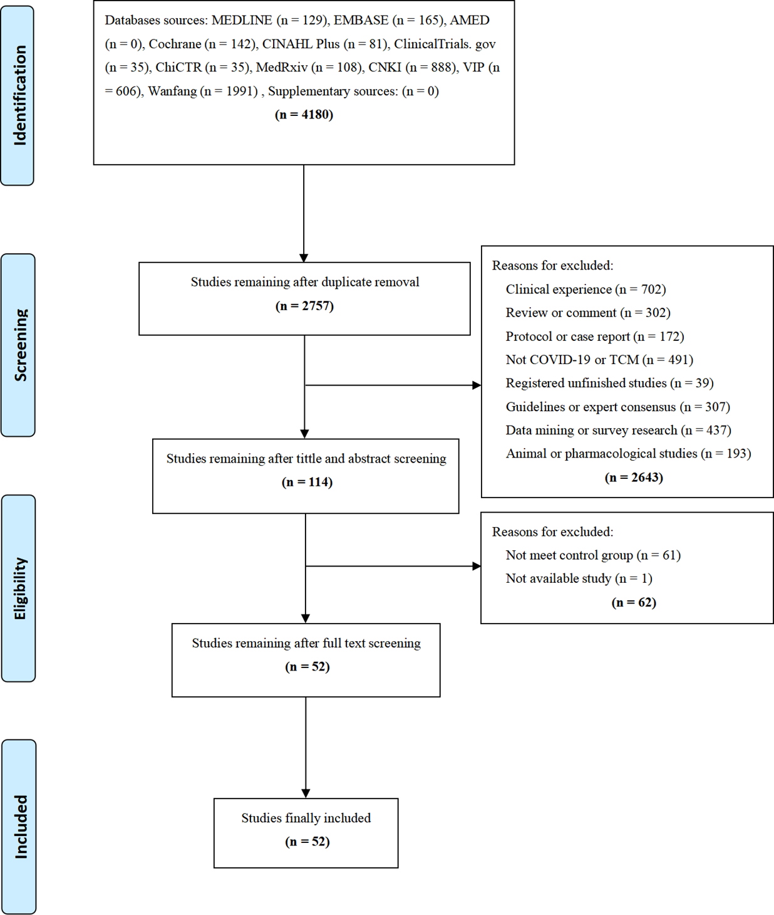
Figure 1

